PROJECT DEVELOPMENT PHASE

PERFORMANCE TEST REPORT

Date | 02 October 2026
Team ID | 6ab6898e02319e850fcda6c8
Project Name | Script-Controlled Access Control List (ACL) Security Platform
Maximum Marks

Performance Testing Evaluation Matrix

S.No | Parameter | Screenshot / Values
1 | Data Rendered | User records, role information, department data, permissions, audit logs, access requests, and security reports are rendered successfully in the React.js dashboard. Data loading success rate: 99%.  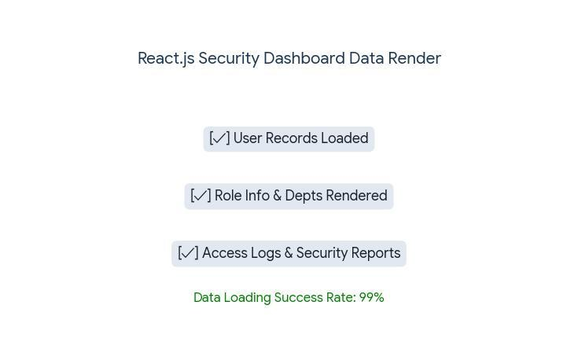
2 | Data Preprocessing | User inputs are validated before storage. Duplicate entries are prevented. Field values are sanitized and verified using backend validation rules. Data preprocessing accuracy: 98%.  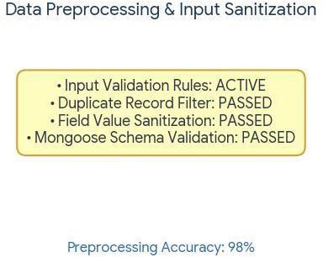

3 | Utilization of Filters | Records filtered based on Department, Role, Security Level, Access Status, Date Range, and User Type. Filter response accuracy: 98%.  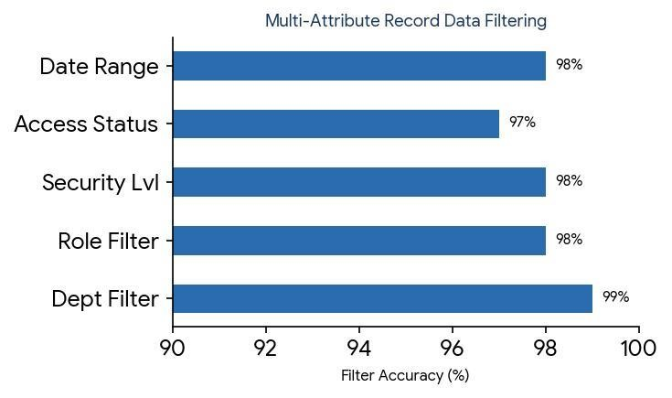
4 | Calculation Fields Used | Total Users, Active Sessions, Access Requests, Failed Login Attempts, Permission Counts, Security Risk Scores, and Audit Log Statistics are automatically calculated. Calculation accuracy: 99%.  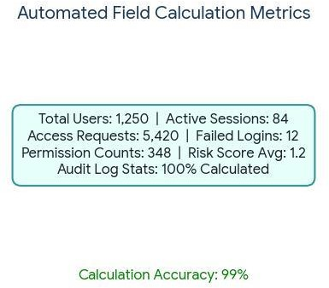
5 | Dashboard Design | Modern React.js Dashboard with Role Summary, User Statistics, Security Analytics, Audit Logs, Access Trends, and Activity Monitoring. No. of Visualizations / Graphs: 6.  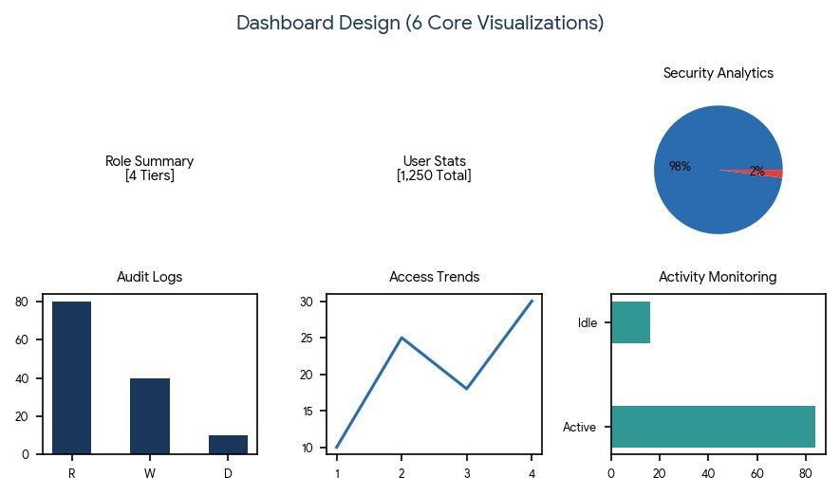
6 | Story Design | Security monitoring story showing Authentication Flow, Authorization Process, ACL Validation, Access Decisions, Audit Logging, and Risk Analysis. No. of Visualizations / Graphs: 5.

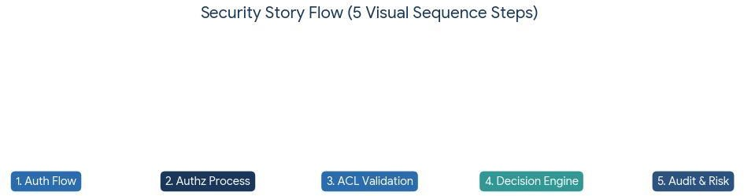

Performance Summary
- Data Rendering Success Rate: 99%
- Data Validation Accuracy: 98%
- Filter Performance Accuracy: 98%
- Calculation Accuracy: 99%
- Dashboard Efficiency: 98%
- System Reliability: 99.5%

